14TH JUNE 2024

DAURA: AN UNDER-WATER OBJECT HIT SB THRUSTER AND LEFT CRACK ON THE THRUSTER HOUSING

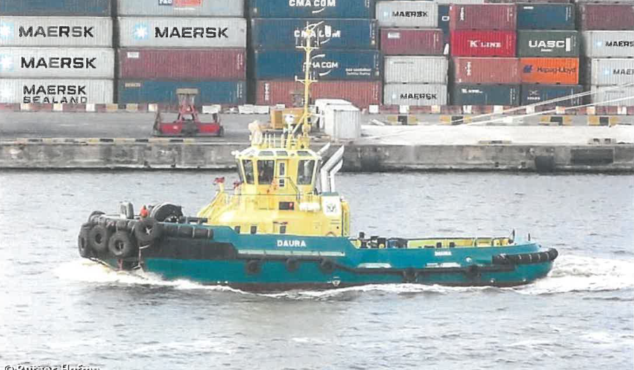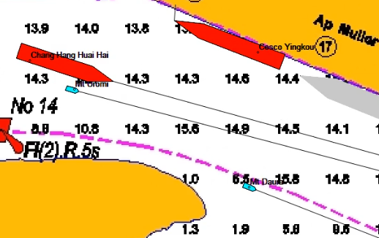
BEING REPORT OF DAURA INCIDENT DATED 12TH JUNE 2024.

LIAV ZILBERMAN

GENERAL MANAGER

MOC INCIDENT REPORT

VESSEL NAME: MT. DAURA
DATE/TIME: 12TH JUNE 2024 (17:55HRS)
LOCATION: OPPOSITE APAPA 17
NATURE OF INCIDENT: UNDER WATER OBJECT HIT SB PROP
IMPACT OF HIT: CRACK ON SB THRUSTER
AID REQUIRE: REPAIR OF THE CRACK
CASUALTY: NIL
STATUS: OUT OF SERVICE & STANDBY FOR DOCKING

NARRATIVE:
AT 17:55 OF 12TH JUNE 2024, CAPT. ROLLY REPORTED THAT SOMETHING HIT THE PROPELLER OF MT. DAURA WHILE ENGAGED IN SHIFTING OPERATION OF “MV. CHANG HANG HUAN HAI” AND REQUESTED FOR DIVE CHECK.
AT 21:35 CAPT. ROLLY FURTHER REPORTED THAT DAURA SB THRUSTER NOT OK, DECLEARED OUT OF OPERATION AND HEADWAY DOCKYA RD FOR DIVE CHECK.
AT 09:3O OF 13TH JUNE 2024, DIVE PERATION COMMENCED AND CONCLUDED AT 10:02. DIVERS REVEALED THAT AN UNDERWATER OBJECT HIT THE SB THRUSTER AND LEFT IT CRACKED.
UPON THE REPORT OF THE DIVERS AND FURTHER EXAMINATION, TECHNICAL DECLEARED DAURA FOR DOCKING REPAIR.
HOWEVER, POST INCIDENT REVIEW REVEALED DAURA OPPOSITE APAPA 17 WENT OUT OF THE CHANNEL AGAINST THE CAPTAIN CLAIMS THAT DAURA WAS IN THE CHANNEL.
BASED ON THE POST INCIDENT REVEALATION, GM DIRECTED THAT CAPT. ROLLY BE ISSUED QUERY. A QUERY WAS ISSUED AND HE RESPONDED.
DAURA OUT OF OPERATION AND SCHEDULED FOR DOCKING EXERCISE.
THE AREA IN WHICH UNDER WATER OBJECT LIKELY STRUCK DAURA THRUSTER WAS THOROUGHLY SURVEYED AND A CONCRETE OF 3MTR LONG, HIGH AND WIDTH WAS DISCOVERED OUT OF THE CHANNEL AND LIKELY THE OBJECT THAT STRUCKED DAURA THRUSTER

LANRE SAHAD


VESSEL NAME: MT. DAURA

CALL SIGN: 5OBU2.

IMO: 9769893

MMSI: 657199500

G. TONNAGE: 294

DWT: 177

FLAG: NIGERIA

LOA: 28

BOLLARD PULL: 60 T.

VESSEL TYPE: TUGBOAT

AIS VIEW OF DAURA MANOUVERING OPPOSITE APAPA 17

PICTURE VIEW OF DIVERS REVEALING CRACK ON DAURA
